|  |
| --- |
| [Type the company name] |
| Word Manual for Students |
| [Type the document subtitle] |

|  |
| --- |
| Sadaqur Rahman  18-Mar-18 |

Contents

**Standards**  
**Font**: Time new roman

**Font size**: 12 (for regular text)

13 & 14 (for heading)

**Line spacing**: 1 (for regular documents)

1.5 (for thesis)

**Font color**: Black

**Alignment**: Justify

**Page size**: A4

**Page margin**: 1”

**Page number**: Bottom

**Generate Table of Contents:**

# 

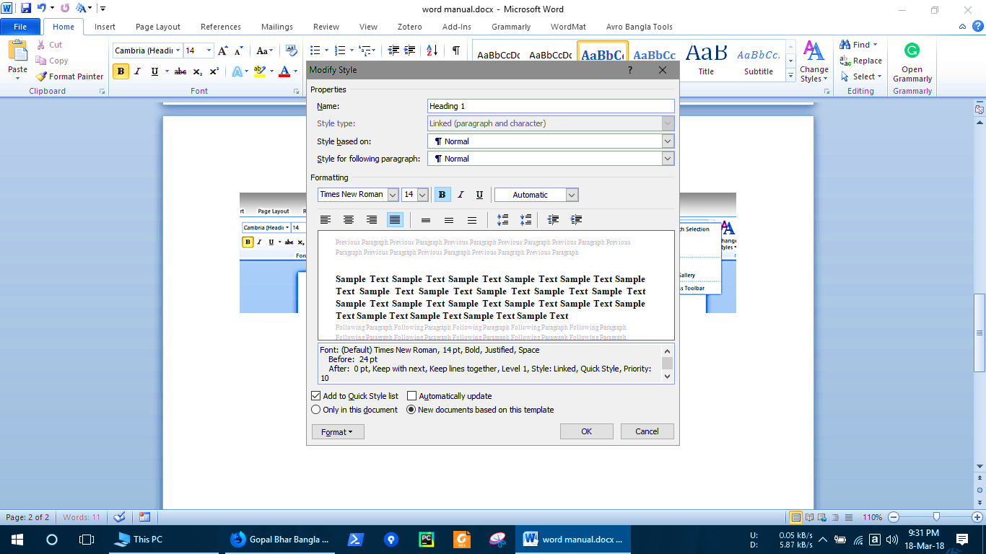

## When heading 2 is in use there will be option for using heading 3 and so on. It can be modified the as needed

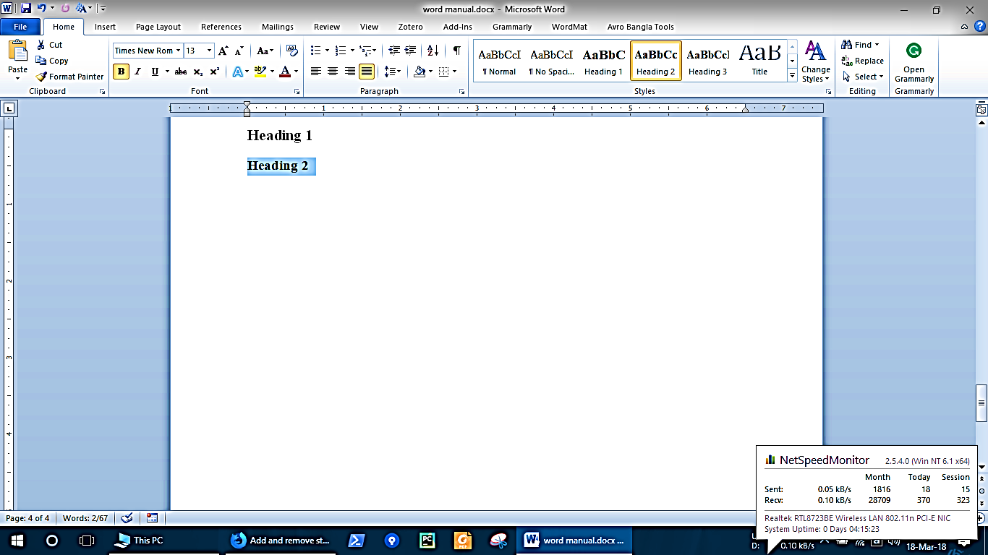

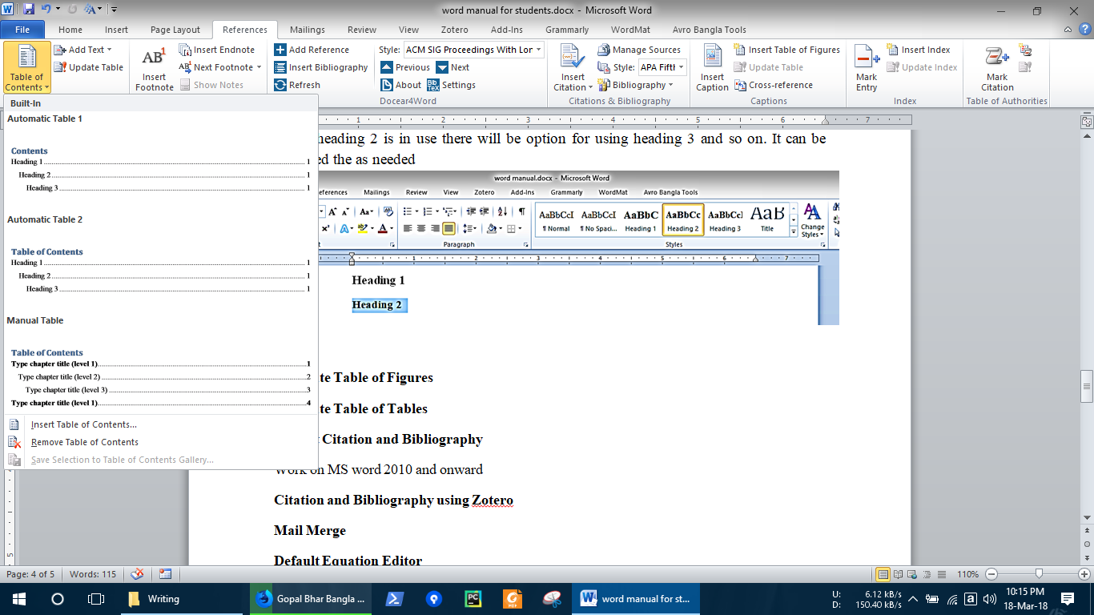

**Generate Table of Figures**

**Generate Table of Tables**

**Default Citation and Bibliography**

EndNote, Zotero, Mendeley, Refworks, Bibtex, JabRef.

Work on MS word 2010 and onward

**Citation and Bibliography using Zotero**

**Default Equation Editor**

**Edit Equation with wordMat**

**Mail Merge**